# Aligning the Australian Social Value Bank to NSW Human Services Outcomes Framework

This document maps NSW Human Services Outcomes Framework to the social values available in the Australian Social Value Bank (ASVB). These are suggested outcomes where we see a correlation in what the outcome is looking to achieve and the values in the ASVB. Organisations may choose to use all or a subset of the recommended outcomes. Certain values are applicable to multiple outcomes in the FACS model and may also be applicable in domains we have not identified in this analysis, based on the work individual organisations are focused on.

# NSW Human Services Outcomes Framework

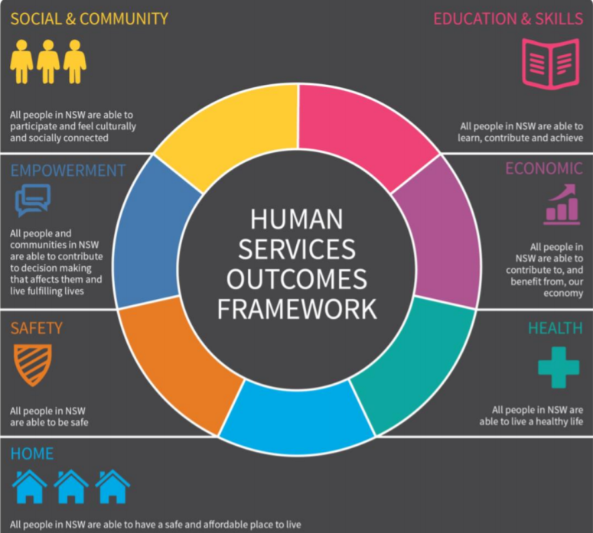

# ASVB Outcomes Mapped to NSW Human Services Outcomes Framework

|  |  |
| --- | --- |
| NSW Framework Domain | ASVB Outcomes |
| Home | * Housing Quality - Reduced impact of noise * Able to make ends meet * Housing is no longer overcrowded * Homelessness to temporary accommodation * Homelessness to secure accommodation * Homelessness to Social Housing * Temporary accommodation to Social Housing * Temporary accommodation to secure accommodation * Improved condition of Social Housing property |
| Social and Community | * Increased involvement in decision making * Improved condition of neighbourhood homes and gardens * Reduced litter problem * Meets friends regularly * Joined a social group * Volunteers * Talks to neighbours regularly * Adequate contact with a non-resident child * Good neighbourhood   + Neighbours do things together   + Neighbours help each other |
| Safety | * Reduced problems with anti-social behaviour * Reduced problems with teenagers hanging around * Reduced problems with vandalism/graffiti * Increased sense of personal safety * Prevented reoffending |

Continued on next page …

|  |  |
| --- | --- |
| NSW Framework Domain | ASVB Outcomes |
| Health | * Improved overall health * No longer obese * Increased levels of walking * Feels in control of life * Accessed free meal programs * Relief from depression/anxiety * Increased hope for the future * Reduced parental stress * Improved diet * Relief from Type 2 Diabetes * Free from Sleeping problems * Improved self-esteem/ confidence * Accessed Family Violence services * Accessed Gambling Support services * Participates in frequent moderate exercise * Accessed support for people who were sexually assaulted as an adult * Increased sense of trust in other people * Relief from Post-Traumatic Stress Disorder (PTSD) * Freedom from alcohol problems * Ceased using Cannabis * Ceased injecting illegal street drugs * Treated for drug and alcohol problems in last year * Ceased smoking   + Social Smoker   + Full time Smoker |
| Education | * Qualification Obtained - Certificate levels III and IV * Completed Year 12 * Improved numeracy * Adequate computer skills * Improved english language skills for non-native speakers * Commenced education - Certificate level I or II * Commenced education - Certificate level III or IV |
| Empowerment | * Increased hope for the future * Feels in control of life * Improved self-esteem/ confidence * Increased involvement in decision making * Increased sense of trust in other people |

|  |  |
| --- | --- |
| NSW Framework Domain | ASVB Outcomes |
| Economic | * Able to make ends meet * People with injuries, illness or disability moving into employment * Obtained casual employment   + equivalent full-time hours   + equivalent part-time hours * Obtained full-time employment * Obtained part-time employment * Became self-employed * Improved job readiness |

## How to apply the ASVB to NSW Human Services Outcomes Framework

The ASVB values closely align to NSW Human Services Outcomes Framework. There is a differentiation in the domains we have used to segment our outcomes list, however the underlying outcome indicators in the majority exist within the ASVB.

To see a full list of our current social values, [download here](https://asvb-media.s3.amazonaws.com/uploads/2017/07/ASVB_Outcomes_2017.pdf).

We recommend organisations workshop the outcomes they are focused on in their programs and map these to outcomes within the ASVB. We are always available to facilitate these exercises as part of a subscription to the ASVB or as a separate piece of scoping work.

The next step is to begin embedding the required evidence stipulated in our User Guide and Value Calculator. This is the data which will be required to ascertain if individuals have achieved the outcome.

This evidence along with details about your program and its associated costs can then be used within the ASVB Value Calculator to create your Impact Valuation Statements.

Please [get in contact](https://asvb.com.au/contact-us/) to subscribe or discuss your social impact measurement approach.